>
>
>
>
>
>
>
>
>
>
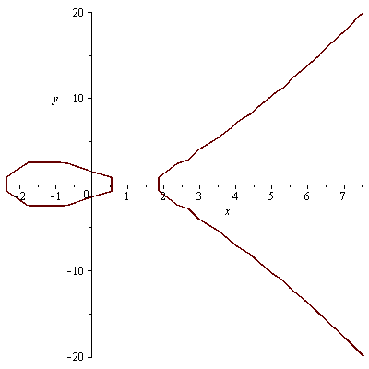
>
>
>
>
>
>
>
>
>
>
>
>
>
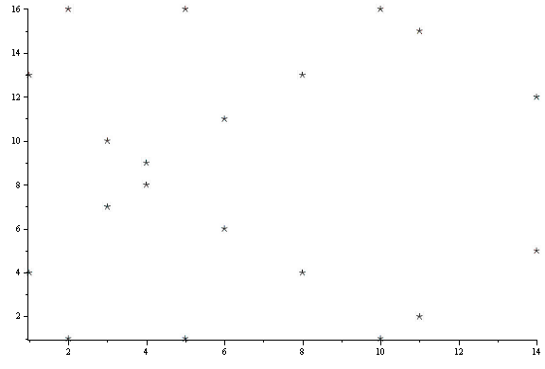
>
>
>
>
>
>
>
Error, numeric exception: division by zero
>
>

